Chelsea Football Club Stadium Development
Chelsea Football Club currently play their home matches at Stamford Bridge, West London. The stadium has a capacity of 41,631 spectators which is considerably lower than the stadiums of rival clubs including Manchester United (76,000) and Arsenal (61,000). The club believe that by increasing the capacity of their stadium, they will significantly increase the revenue earned from ticket sales and merchandising. As a result, they are considering moving to a new stadium or redeveloping of Stamford Bridge to increase its capacity. The financial projections are included in the table below. These assume that the club sells all available tickets for each home match.
Year | Option A Net Cashflow (£millions) | Option B Net Cashflow (£millions) | Option C Net Cashflow (£millions)
0 | (600) | (1,100) | (900)
1 | 0 | 0 | 0
2 | 0 | 0 | 0
3 | 0 | 0 | 0
4 | 0 | 0 | 0
5 | 100 | 100 | 100
6 | 105 | 120 | 120
7 | 110 | 150 | 150
8 | 115 | 180 | 180
9 | 120 | 180 | 180
10 | 125 | 180 | 180
11 | 130 | 180 | 180
12 | 130 | 180 | 180
13 | 130 | 180 | 180
14 | 130 | 180 | 180
15 | 130 | 180 | 180
16 | 130 | 180 | 180
17 | 130 | 180 | 180
18 | 130 | 180 | 180
19 | 130 | 180 | 180
20 | 130 | 180 | 180
- Using the information provided, carry out an investment appraisal and recommend which option Chelsea should choose based on financial considerations (10)
- Using the information provided in the case study and the calculations you have produced in part (a), discuss which option would be the best choice (20)
- Evaluate the use of an investment appraisal in this situation (10)
Chelsea have also carried out some research and sales forecasting based on a number of possible scenarios, taking into account the impact of the football team performance level on the business outcomes. They have come to the following conclusions:
- The likelihood of the club filling the stadium for every match is 0.8 for options A and B
- The likelihood of the club filling the stadium for every match is 0.6 for option C
- The drop in revenue if the stadium is not full would be 25% for Option A and 20% for Options B & C
- Use this information to construct a decision tree to show the options available (6)

Option A
A meeting of the planning and development committee of Hammersmith & Fulham council unanimously approved plans submitted by the club for a new stadium that would cost at least £500m and could be completed in time for the 2021-22 season. In a further vote, the council agreed to revisit some concerns about the plans, including the ability to park near the ground and construction and demolition planning.
With a pitch below ground level and underground entrances for home and away fans, it will be a very different stadium from that which Chelsea have called their home since 1905. In order to maximise the scale of the new stadium, buildings that surround the current Stamford Bridge, known as the Chelsea Village, will be demolished. There will also be broad walkways built over the two rail lines that flank the stadium.
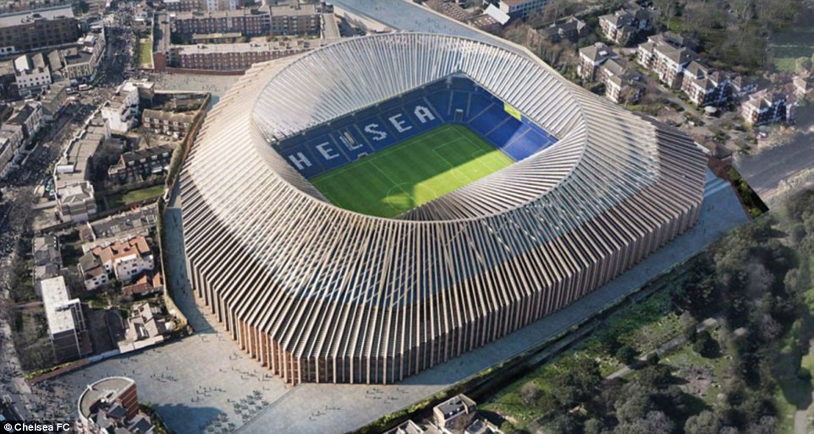
The new ground would have more than 13,000 extra seats for general admission, while corporate seating would double to 9,200. There would also be expanded provision for disabled supporters, but the seats afforded to visiting fans would remain the same, at 3,000.

Development will mean that the football club will be forced to find a temporary home for around three seasons. Wembley Stadium remains an option, though Tottenham already have a groundshare deal in place there for next season. Relocating to the national rugby stadium at Twickenham has also been mooted.
What has been key for the new plans to be approved is that 70 per cent of the local residents are in favour of the expansion of the ground as well as the new design. Chelsea are confident that they will be given the green light to start the works on the stadium, they will probably look for a similar deal to what Tottenham have struck with Wembley whilst their ground is redeveloped.
Case officer John Sanchez briefed councillors ahead of the meeting on Wednesday and said: ''The design has met the demands of a potentially difficult brief and builds upon the historic context of previous stadia on the site.''
Sanchez added: “The resulting design is a high quality piece of design and a unique architectural solution. It would have the landmark qualities of a significant sporting venue with a clear identity and would declutter and unify the site."

Option B
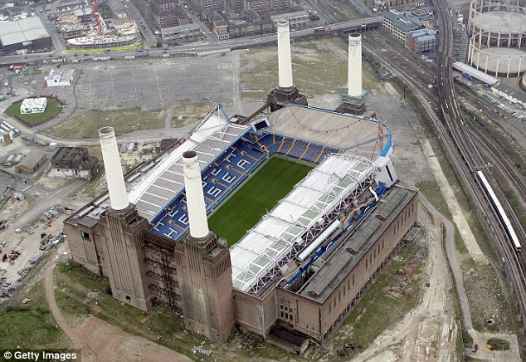
Chelsea have submitted a formal offer to purchase the site of Battersea power station which, if accepted, could lead to the club leaving Stamford Bridge and the development of "one of the most iconic football stadiums in the world" at a cost of more than £1bn. The move attracted fierce opposition from sections of the club's fanbase, but senior figures have continued to press ahead with the proposal.
'As per our previous statement, and as these images show, we believe the prospect of developing a new stadium on the site could be very attractive for the club, and would have the potential to become one of the most iconic stadiums in the world, offering many benefits for Wandsworth, for London, and, of course, for Chelsea fans.
'The design would integrate the stadium with the power station in a sensitive, unique and powerful way, with all significant historical aspects of the Power Station to be retained.

'In creating an iconic world-class stadium we would preserve the four chimneys and wash towers along with the historically significant west turbine hall and control room, all to be restored and retained in their original locations.'
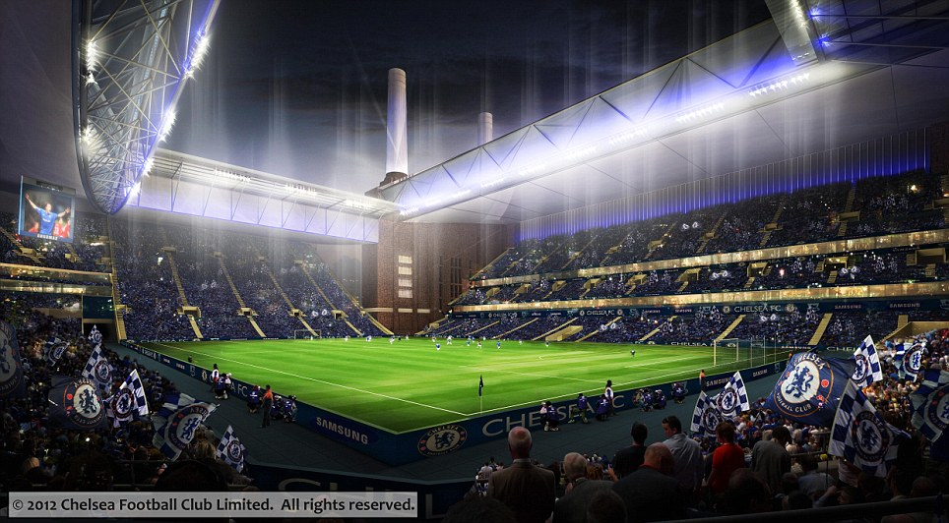
The Grade II* listed former electricity power station was put up for sale earlier this year following the collapse last November of an Irish-backed scheme to revamp the area, with the site having been valued at around £500m a month earlier. That price could have fallen since, given the economic climate, though Chelsea have not revealed the size of their bid. Regardless, the site will be sold with the planning permission, secured from Wandsworth council in 2010 by the former owner Treasury Holdings, for homes, offices, hotel, retail and leisure developments, and with the associated commitments.
That planning permission requires full restoration of the power station, at an estimated cost of £150m, which Chelsea would attempt to incorporate into the design for a 60,000-seater stadium, with all four chimneys and wash towers, along with the Grade II listed west turbine hall and control room, to be retained in their original locations.
There is optimism within the club's hierarchy that their proposals would maintain the essential character of the building, currying favour with heritage authorities. The club has also pledged to make a "significant contribution", believed to be around £200m, towards the Northern Line extension from Kennington via Nine Elms to connect the proposed newstadium to the London Underground network. The development would also include a town centre with street-level retail units, housing and offices. Construction would be likely to take up to four years.

Option C
The club also have a third option which involves moving to a new stadium in Battersea but not extending the underground line to the new location. This would reduce the initial investment by £200 million but make accessing the ground and surrounding amenities more difficult for supporters and local residents.

