Critical Path Analysis CPA (Network Analysis)
Critical Path Analysis (CPA) is a project management tool that:
- Sets out all the individual activities that make up a larger project.
- Shows the order in which activities have to be undertaken.
- Shows which activities can only taken place once other activities have been completed.
- Shows which activities can be undertaken simultaneously, thereby reducing the overall time taken to complete the whole project.
- Shows when certain resources will be needed – for example, a crane to be hired for a building site.
In order to construct a CPA, it is necessary to estimate the elapsed time for each activity – that is the time taken from commencement to completion.
Then the CPA is drawn up a based on dependencies such as:
- The availability of labour and other resources
- Lead times for delivery of materials and other services
- Seasonal factors – such as dry weather required in a building project
Once the CPA is drawn up, it is possible to see the CRITICAL PATH itself – this is a route through the CPA, which has no spare time (called ‘FLOAT’ or ‘slack’) in any of the activities. In other words, if there is any delay to any of the activities on the critical path, the whole project will be delayed unless the firm makes other changes to bring the project back on track.
The total time along this critical path is also the minimum time in which the whole project can be completed.
Some branches on the CPA may have FLOAT, which means that there is some spare time available for these activities.
What can a business do if a project is delayed?
- Firstly, the CPA is helpful because it shows the likely impact on the whole project if no action were taken.
- Secondly, if there is float elsewhere, it might be possible to switch staff from another activity to help catch up on the delayed activity.
- As a rule, most projects can be brought back on track by using extra labour – either by hiring additional people or overtime. Note, there will be usually be an extra cost. Alternative suppliers can usually be found – but again, it might cost more to get urgent help.

The Key Rules of a CPA
- Nodes are numbered to identify each one and show the Earliest Start Time (EST) of the activities that immediately follow the node, and the Latest Finish Time (LFT) of the immediately preceding activities
- The CPA must begin and end on one ‘node’ – see below
- There must be no crossing activities in the CPA
- East activity is labelled with its name eg ‘print brochure’, or it may be given a label, such as ‘D’, below.
- The activities on the critical path are usually marked with a ‘//’
In the example below
- The Node is number 3
- The EST for the following activities is 14 days
- The LFT for the preceding activities is 16 days
- There is 2 days’ float in this case (difference between EST and LFT)
- The activity that follows the node is labelled ‘D’ and will take 6 days
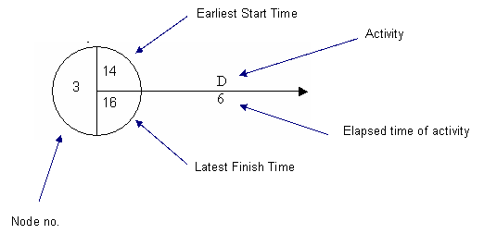
A Simple Example – Baking a Loaf of Bread
Here is a simple example, in which some activities depend on others having been undertaken in order, whereas others can be done independently.
Activity | Preceded by | Elapsed time (minutes)
A weigh ingredients | - | 1
B mix ingredients | A | 3
C dough rising time | B | 60
D prepare tins | - | 1
E pre-heat oven | - | 10
F knock back dough and place in tins | C&D | 2
G 2 nd dough rising time | F | 15
H cooking time | E & G | 40

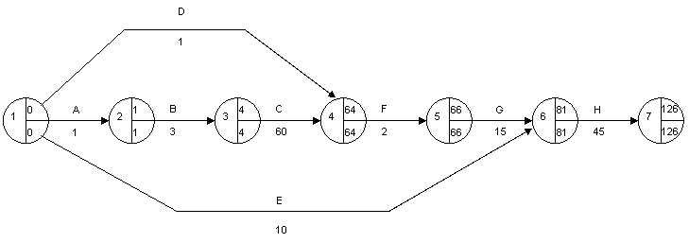
In this example, there is a clear sequence of events that have to happen in the right order. If any of the events on the critical path is delayed, then the bread will not be ready as soon. However, tasks D (prepare tins) and E (heat the oven) can be started at any time as long as they are done by the latest finish time in the following node.
So, we can see that the oven could be switched on as early as time 0, but we can work out that it could be switched on at any time before 71 – any later than this and it won’t be hot enough when the dough is ready for cooking. There is some ‘float’ available for tasks D and E as neither is on the critical path.
This is a fairly simple example, and we can see the LST and LFT are the same in each node. In a more complex CPA, this will not necessarily be the case, and if so, will indicate that there is some ‘float’ in at least one activity leading to the node. However, nodes on the critical path will always have the same EST and LFT.

Evaluation
CPA is a planning and project management tool. Whilst it can help ensure a project is completed as quickly as possible, and resources used as efficiently as possible, it does depend on the accuracy of the information used.
Just drawing up a CPA will not in itself ensure a project runs to plan; most projects encounter some delay or something unexpected, so managers need to use tool such as CPA to monitor the project and take swift action to rectify any problems.
These days, businesses use a software package such as Microsoft © Project ® to draw up and manage a CPA.

