Opportunity Cost

What is an opportunity cost?
An opportunity cost is quite literally the cost of an opportunity that has been sacrificed for something else. Individuals, businesses and governments all face opportunity costs in every decision they make.
For example, say a man wanted to go to the cinema this evening but also wanted to have a BBQ with his friends. If he went and watched a film in the cinema the opportunity cost to the man would be the time and enjoyment lost out by not having a BBQ with his friends.

Why is it significant?
Opportunity cost is an important economic concept that is inherent in the decision-making of individuals, businesses and other entities.
The famous saying that ‘there is no such thing as a free lunch’ is exactly what opportunity cost is all about. If someone invites you out for a free lunch, is it completely free? Absolutely not. The potential opportunities that you could be doing whilst having this lunch have been sacrificed – which comes at a cost – an opportunity cost.
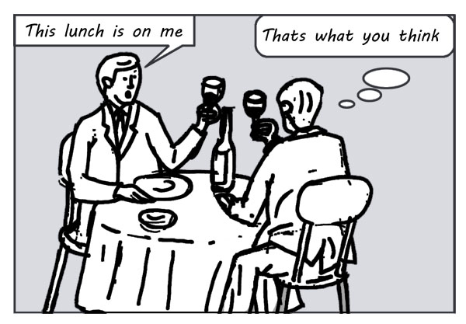

Opportunity cost for individuals
Individuals encounter opportunity costs every day. Should you carry on reading this article instead of watching your favourite TV programme? In every decision you make you will have weighed up the benefits of choosing each option and calculated which option will give the lowest opportunity cost.
Opportunity cost is an important concept because it shows why people make certain choices. For example, if someone chooses to go to university for three years they must think that studying for this period of time will be worth the opportunity cost of not having a job for three years which provides paid employment and work experience.

Opportunity cost for businesses
Businesses and corporations are also faced with opportunity costs. If a business decides to invest £50,000 into a new factory in order to expand its production, there are large opportunity costs involved. The money could be spent on new equipment in order to increase productivity (the efficiency of the use of resources). On the other hand, there is also an opportunity cost of not keeping the money in a bank account where it will collect interest payments.
Businesses also face opportunity costs when deciding to shut down or change a part of its operations. For example if a retail business wants to move one of its stores from the centre of the city to the middle of the countryside the opportunity costs will be the lost profits of the store in the city. If the store in the city made £10,000 a week of profit and the new store in the countryside is making £15,000 a week profit then you may think that the decision to close the store in the city has resulted in large benefit of £15,000 a week. However, by not having the store in the city, the business is no longer making that £10,000 a week so the actual economic profit from this decision is £5,000 (£15,000 minus £10,000) due to the opportunity cost involved.

