Recruitment and Selection Evaluation
When working on questions at IB Level, it is often a case of showing the extent of your understanding of a situation and being able to apply theory you have learned to the situation.
In such circumstances it is all about how you use your knowledge rather than how much or how detailed your knowledge is.
You must, therefore, be selective with your knowledge and remember the assessment objectives for this type of question - mostly analysis and evaluation. Analysis means breaking down an issue into component parts to make it more understandable and criticism and evaluation is about making judgments about the relative importance of these component parts to the question you have been asked.
This activity will give you a scenario - based on a true event - and asks you to consider the event in a critical manner - that does not mean being negative, it means looking at what happened, trying to explain why things happened as they did and making decisions to try to avoid problems in the future whilst encouraging the continuation of the good things that came out of it.
This is what businesses have to do all the time and requires decision makers to use all their knowledge and experience to reflect and review their procedures to try and ensure that decision making and productivity are improved.
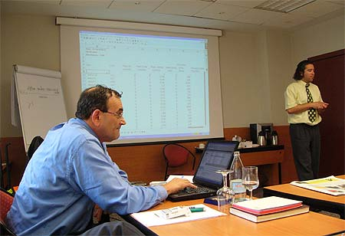

The Scenario
A medium sized business was seeking to recruit a product development manager in its research and development (R&D) section. The new person would be responsible for overseeing the process by which the new products the business was developing were prepared for launch onto the market.
The recruitment process involved placing adverts in trade magazines and the national press and the adverts resulted in over 60 applications. There were 5 people involved in the short listing process: the direct line manager; the head of the HR division; the assistant head of that division; and two members of the new product development department - one from R&D and one from the launch team.
A short list of 7 candidates was drawn up. However, the assistant head of HR heard that a former trainee of the firm wanted to apply but could not get the application in by the deadline - she would be a strong candidate and the firm knew of her qualities. The head of HR agreed to let the application come in three days late and she was duly added to the shortlist.
On the day of the selection, each candidate had to do a presentation on the extent to which they matched the job description and person specification and what they felt they could bring to the job to further the company's objectives. This was followed by an interview. The candidate who had put in the late application did not turn up and the head of HR phoned her up. She said that she had not received a letter inviting her for interview and was not therefore aware that she was wanted. She agreed to come in and was allowed to miss doing the presentation although would be questioned on it in the same way that other candidates were.
At the end of the process, two clear candidates emerged, one of which was the late applicant. It was decided that she would be offered the position and after receiving the phone call from the assistant manager of the HR department, she duly accepted. The rest of the selection team took the responsibility of contacting the other candidates to tell them they were unsuccessful and to give them some feedback about their performance and why they were unsuccessful.
Later that evening, the head of HR received a phone call from the successful candidate telling her that she had gone back to her company where she had been working part time and told them of her success. They had responded by offering her a full time position and increasing her salary and she had decided to stay with them and thus did not want the position.
This meant that the candidate who was second had to be contacted and have the position explained to him. Fortunately for the firm, he understood and was happy to accept the position. Had he not, it could have involved the business in another round of selection which is an expensive process.

The Task
Critically assess the recruitment and selection procedure of the firm in the light of this experience and write a 500 word report to the head of Human Resources on recommendations for any changes to the recruitment process for the firm.

Things to Consider
The following questions are provided to guide you in your thinking and critical analysis.
- Is the method of advertising for new positions appropriate?
- Is the method of sifting through the applications and shortlisting efficient and effective?
- How effective a means of discrimination between candidates is the presentation and interview process?
- How far would you say that the firm's process meets employment legislation in terms of equal opportunities?
- What lessons might be learned about the selection process from what happened in the scenario?
- What implications might there be on motivation, training and development from the way the eventual appointment was made?
- Is the method of providing feedback to unsuccessful candidates appropriate?

