Tip Based Tours
Objectives:
- Offer tours around Kraków for tourists
- Open up service this summer
- Start making profits within the first 3 months of start up

Target Market:
- Tourists
- British, German, Israeli and Jewish
- B, C1 (mainly), possibly A
- Ages 20-55
- Couples and groups of friends between 20-55 (mainly), families with older kids
Product
- Customer takes part in tour of city (taken to most important places of city (e.g. historical sites). Pro gives a wide overview of city however isn’t as in depth as specific tours. Good for people who are not too focused on indulging in a certain aspect of the city. Also, helps tourists figure out what they may want to see in more depth after the tour.
- Tour can be adjusted to meet the consumers’ needs (tour guide can change plans to accommodate for peoples’ needs and wants by analyzing participants and talking to them about what they want to see and learn about). Flexibility makes the tour more enjoyable for participants. Motivation for guide as it gives them a bit of a change. However some people may want to know exactly what they will see, and participants may having conflicting interests making it difficult to accommodate for everyone’s needs and wants.
- We’ll start off by introducing the tour in Kraków as it is the ‘tourist’ magnet and historical capital of Poland. Most tourists and our target market go there. Lots of historical sites to show. Has relatively good infrastructure with good links to neighbouring countries.

Promotion
- Advertisements in tour guides (e.g. lonely planet and national geographic). Most tourists buy them, so high exposure to our target market. Advertisement presents a cost, however it should be quite moderate in this case. Therefore quite good idea as most of target market sees it.
- Leaflets in hotels’ reception. Cheap, only really printing costs as hotels usually allow to leave leaflets in the reception hall for tourists as it improves the guests’ experience and could improve image of hotel as guests have more information. High exposure, most of the target market will see them, and leaflet can be kept for future reference. Some people take leaflets and throw away, COST.
- If affiliated with LOT announcements in airplane, adverts in LOT magazine, leaflets given out at start of flight, logo on ticket. Reminds passenger about the tour, however may be annoying. Also, not all passengers are tourists so adverts aren’t relevant. Low cost.
- Advert on tripadvisor and similar websites. Relatively low cost. Adverts can be made relevant to user through cookies. High exposure to target market. However, consumers often use these websites well in advance of trip and may forget about the advert.
- Facebook page, low cost. High exposure but possibly too few in target market. Photo service, e.g. photo at the end of trip which is posted on the fb page attracts ex-customers to see photo. People see news feed if you liked something about the page or commented. They may check out the page and gain info, and may decide to visit city because of recommendations from friends.

Price
- Decided by consumer. Pay as much as you want USP. Motivates tour guides to try the best as they are paid based on tips (commission). Also, participants are socially obliged to pay because of peer pressure. And participants have free will and often pay more than usually as a result (psychological trick). Risk of people not paying as it is purely based on tips, however unlikely.

Place
- We chose Kraków, because it is the most historical and touristic city in Poland. Tourists from Israel, Germany, Russia and all over Poland visit Kraków in all seasons. These tourists are our target customers, because they are usually wealthy and over 30.
- There are lots of historical places and site-seeing opportunities
- Kraków already has a developed tourism market, there are many touris around the city available, however tip based ones do not exist yet. Therefore, this service will be unique and new. A disadvantage of this, might be that since it is new, it’s a huge risk because we don’t know if it will work out and fit the needs of the customers.
- In winter there is still a lot of tourists coming. This is why, in winter the tours still function normally, but the daily plan is shorter and the tours don’t last that long.
- If successful, possible expansion to other cities, ex. Kazimierz.

People
- 2 tour guides, working 9-18, changing every few hours.
- The tour guides are young, organized student with good communication skills. They can speak English, German and Polish.
- The guides are self-motivated, and aware that their wages depend on how well they perform during each tour,.
- They get a minimum wage, but mostly earn what they receive as tips from customers. 50% of the total tips go to the owner, to be spent on promotion etc.
- They have flexible working hours, and can adjust to the hours that the customers prefers.
- A disadvantage of employing a student, may be that he is inexperienced in the job, could have not enough knowledge.
- It may also be hard to find a person, who would not be demotivated by such a low wage. At the beginning the tips may be really low, and so the employees may feel a bit disappointed and lose their motivation and enthusiasm.

Physical Environment
An important element of the marketing mix is the physical environment of the business. The physical environment is how, physically, the place where the business operates appears to customers. Tip-Based Tours is a service, where the physical environment itself is not particularly important, as the majority of the service takes place outside of it.
The way Tip-Based Tours operates is by having booths on wheels located around the city. We plan to start off with only one booth - in the Old Town of Cracow, and later, if we discover there’s enough interest with our service, we plan to expand to having more booths. The booths serve two purposes: so that our service can be located (a booth is much easier to find than a tour guide walking around randomly around the Old Town), as well as so that the guides have a place to rest and provide any necessary information to interested tourists between tours. The booths will have be painted in their corresponding town colors - so white and blue in Cracow, and if we choose to expand to eg. Warsaw, yellow and red, etc.
Such a physical environment has several advantages. First of all, the booths are very universal. They can be moved around the city, easily wheeled off to Sukiennice to be stored at night; generally, this allows more flexibility with the location of our service than a fixed local. Second, the booths welcome tourists with city colors, giving them a welcoming, patriotic feeling. This, in turn, may lead tourists to be more attracted to the booth, as they may feel that it reflects the national identity better than other tour services. Moreover, using vibrant colors may attract more attention, therefore leading more potential customers to actually noticing Tip-Based Tours. Third, using an open booth improves communication, as it allows potential customers to simply stand in front of it and talk, rather than need to go through a series of doors, sitting down, etc.
However, the usage of a booth on wheels also has some disadvantages. First of all, since it will be easy to access, it will be exposed to the threats of vandalism and theft. This means that a booth may never be left standing alone, as it may get destroyed by vandals. Consequently, there always has to be an employee at a booth to ensure its safety - meaning that, from scratch, at least two employees (rather than one) will be needed, decreasing the profit made from the business. Also, if not well-designed, a booth may look unprofessional, and may actually repel potential customers from approaching Tip-Based Tours, as they will not feel as if it’s a business one can depend on.
Overall, a series of colorful booths on wheels may be an effective physical environment, as the not only give our business an established location and a place for the guides to rest, they are also easy to move around, and allow for easy communication between the employee and customer. On the other hand, a wheeled booth may be destroyed by vandals if unattended, and, if not well-designed, may not appear attractive. Both of those disadvantages, however, may be overcome by spending more money on a well-designed booth and more employees.
Process
Another element of the marketing is the process - so how the product/service actually reaches the customer. Since Tip-Based Tours is a service-providing business, the process takes into account the entire process of how the service is carried out.
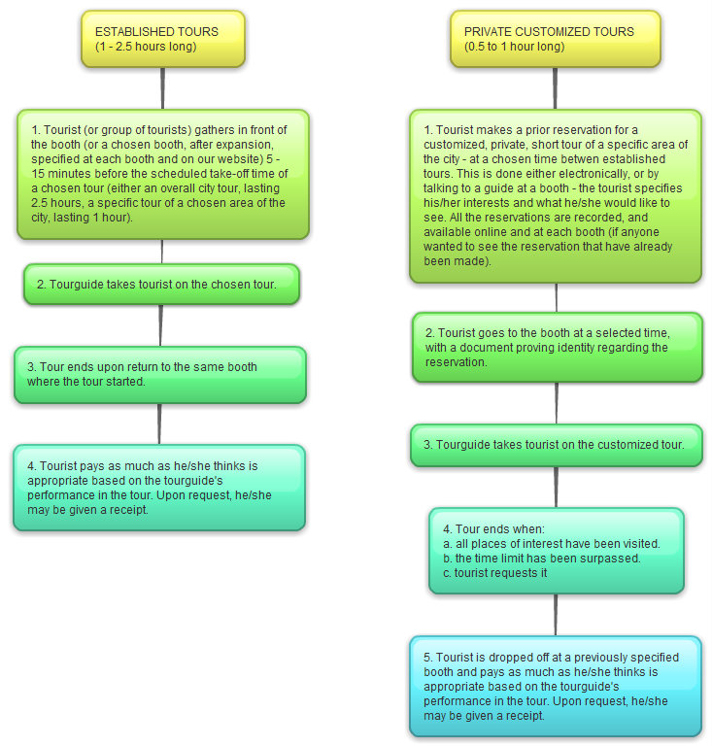
Below is a mind map, showing the two different types of service offered at Tip-Based Tours - established tours, and private customized tours.

Below is the schedule of the overall and specific tours for Cracow, where Tip-Based Tours will first operate. It is important to note that Day 1 and Day 2 will alternate; ie. Day 1 will be every other day, and Day 2 will be every other day.

Tour time frame | Type of tour | Length of tour (h) | Where to?
 |  |  | Day 1 | Day 2
9:00 - 11:30 | Overall | 2:30 | --- | ---
12:00 - 13:00 | Specific | 1:00 | Cemeteries around the center | Zabłocie and Schindler’s Factory  (outside only)
13:30 - 14:30 | Specific | 1:00 | Churches around the center | Lasek Wolski (and the Camaldolese Priory - seasonally; the tour is then exceeded until 15:00)
15:00 - 17:30 | Overall | 2:30 | --- | ---
18:00 - 19:30 | Specific | 1:30 | The Wawel castle and its surroundings | Tyniec and the Benedictine Monastery
19:30 - 21:00 | Specific | 1:30 | Kazimierz (the Jewish district) | The center at night (including the Wawel castle)
Note that the customized tours (described in the mind map on the previous pafe) can be 1 hour long only if they take place from 21:00 to 22:00. Otherwise, they have to be 30 minutes long.
Such a process is very similar to a typical tour service. Our USP, however, is the differentiation between overall, specific, and private customized tours, as well as the opportunity to pay as much as one thinks is appropriate. Therefore, one advantage of the process is that it is gives the customers more freedom with deciding what they want to see, as well as how much they want to pay (unlike with other tour services) - therefore possibly causing Tip-Based Tours to attract more customers. Also, the process is quick and simple, requiring no complicated procedures - all the customers have to do is come to our booth at an established time, go through the tour, and pay as much as want. This is true even with the customized tours - scheduling a tour cannot take more than 15 minutes.
On the other hand, the process has a few disadvantages. First of all, there is always the risk involved that a certain tourist may leave the group right before the step regarding payment, or may choose not to pay (after all, it’s not obligatory). This, in turn, means that he/she has used our service without any profit for us, causing us to lose revenue. Also, the customized tours may fail due to a very strict schedule - and 30 minutes might not be enough to see certain parts of the city.
Overall, there are large advantages to the whole procedure. The ability to specifically adapt the tour to one’s interest and to pay as much as one likes is very likely to attract many customers who do not enjoy other tour guide services, due to only providing them with overall tours, or with too high prices. Moreover, the procedure is very easy to follow, making it unlikely for any customers to be confused with it. However, the process may yield no profit, due to the lack of a fixed price, and the process of customized tours may fail due to a inflexible tour schedule. Without trying to implement those ideas, however, such risk has to be taken into consideration, and may be further experimented with once the idea of Tip-Based Tours reaches the market.

